DESIGN SKELETON
PROJECT | COMP6710 ASSIGNMENT2
GROUP | tue10b4
MEMBERS | Xinyang Li, Tashia Tamara, Jiangbei Zhang

Class Diagram

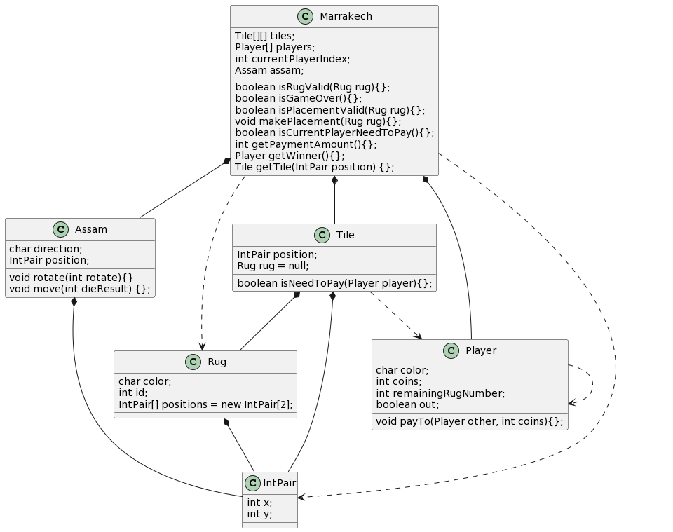

@startuml
class Player {
char color;
int coins;
int remainingRugNumber;
boolean out;
void payTo(Player other, int coins){};
}

class IntPair {
int x;
int y;
}

class Marrakech {
Tile[][] tiles;
Player[] players;
int currentPlayerIndex;
Assam assam;
boolean isRugValid(Rug rug){};
boolean isGameOver(){};
boolean isPlacementValid(Rug rug){};
void makePlacement(Rug rug){};
boolean isCurrentPlayerNeedToPay(){};
int getPaymentAmount(){};
Player getWinner(){};
Tile getTile(IntPair position) {};
}

class Assam {
char direction;
IntPair position;
void rotate(int rotate){}
void move(int dieResult) {};
}

class Rug {
char color;
int id;
IntPair[] positions = new IntPair[2];
}

class Tile {
IntPair position;
Rug rug = null;
boolean isNeedToPay(Player player){};
}

Marrakech *-- Tile
Marrakech *-- Player
Marrakech *-- Assam
Marrakech ..> Rug
Marrakech ..> IntPair
Assam *-- IntPair
Player ..> Player
Tile *-- IntPair
Tile *-- Rug
Tile ..> Player
Rug *-- IntPair
@enduml

Game Flow

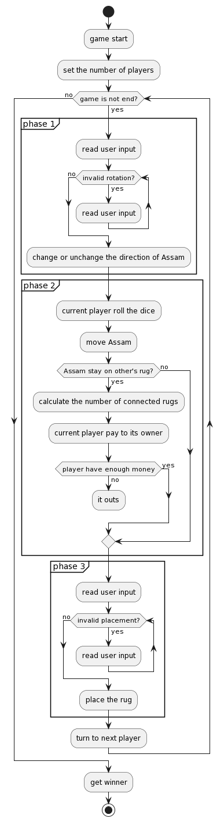

@startuml
start

:game start;
:set the number of players;

while (game is not end?) is (yes)
partition phase 1{
:read user input;
while (invalid rotation?) is (yes)
:read user input;
endwhile (no)
:change or unchange the direction of Assam;
}

partition phase 2{
:current player roll the dice;
:move Assam;
if (Assam stay on other's rug?) then (yes)
:calculate the number of connected rugs;
:current player pay to its owner;
If(player have enough money) then (yes)
else (no)
:it outs;
kill
endif
else (no)
endif
}

partition phase 3{
:read user input;
while (invalid placement?) is (yes)
:read user input;
endwhile (no)
:place the rug;
}

:turn to next player;
endwhile (no)

:get winner;

stop
@enduml

